SMART MONITORING TECHNOLOGY

Submitted in partial fulfillment of the requirements
Of the degree of
Bachelors of Engineering
By
ABBAS ALI (08)
RAHIM KORBO (14)
SHAHRUKH PADANAIYA (19)
VISHAL KERKAR (10)

Guide:
(DR. VARSHA SHAH)


Electronics Engineering Department
Rizvi College of Engineering


University of Mumbai
2017-2018

CERTIFICATE
This is to certify that the project entitled “SMART MONITORING TECHNOLOGY” is a bonafide work of “VISHAL KERKAR (ROLL NO.10) RAHIM KORBO (ROLL NO:14),SHAHRUKH PADANAIYA (ROLL NO:19), ABBAS ALI (ROLL NO:08)” submitted to the University of Mumbai in partial fulfillment of the requirement for the award of the degree of “Bachelor of Engineering” in “Electronics Engineering”.

(Name and sign)
Guide

(Name and sign) (Name and sign)
Head of Department Principal

Project Report Approval for B.E.
This Project report entitled “SMART MONITORING TECHNOLOGY” by (ABBAS ALI , RAHIM KORBO , SHAHRUKH PADANIYA , VISHAL KERKAR) is approved for the degree of Bachelor of ELECTRONICS Engineering.

Examiners

1. ---------------------------------------------

2. ---------------------------------------------

Guide

1. ---------------------------------------------

2. ---------------------------------------------

Date:

Place:

DECLARATION
I declare that this written submission represents my ideas in my own words and where others' ideas or words have been included, I have adequately cited and referenced the original sources. I also declare that I have adhered to all principles of academic honesty and integrity and have not misrepresented or fabricated or falsified any idea/data/fact/source in my submission. I understand that any violation of the above will be cause for disciplinary action by the Institute and can also evoke penal action from the sources which have thus not been properly cited or from whom proper permission has not been taken when needed.

( )
ABBAS ALI (08)

( )
RAHIM KORBO (14)

( )
SHAHRUKH PADANIYA (19)

( )
VISHAL KERKAR (10)

Date:

ABSTRACT

APPARENTLY THE CURRENT SCENARIO STATES THAT AUTHENTICITY IS AN IMPORTANT FACTOR IN VARIOUS FIELD OR VARSITY. EG. DEFENCE, DATA STORAGE, ECONOMY SECTORS. AS THE TECHNOLOGY GROWS IN ASPECTS , THERE ARE CLOSED CIRCUIT TELEVISION POPULARLY KNOWN AS CCTV WHICH ARE OF IMMENSE WORK FOR MONITORING AND SECURING PURPOSE WITH A WELL CALCULATED ACCURACY . DUE TO EXPONENTIAL RISE IN BURGLARY AND THEFT ACTIVITIES, SURVEILLANCE SYSTEMS ARE PROVING TO BE A GREAT SOURCE OF SECURITY. IN THIS PROJECT WE ARE ON FOR MAKING THE WORD AUTHENCITY TRUE IN THE FORM OF THIS DEDICATED PROJECT OF SMART MONITORING TECHNOLOGY.
WHILE INTELLIGENT ENVIRONMENTS ARE OFTEN CITED AS A REASON FOR DOING WORK ON VISUAL PERSON-TRACKING, REALLY MAKING AN INTELLIGENT ENVIRONMENT EXPOSES MANY REAL-WORLD PROBLEMS IN VISUAL TRACKING THAT MUST BE SOLVED TO MAKE THE TECHNOLOGY PRACTICAL. IN THE CONTEXT OF OUR EASYLIVING PROJECT IN INTELLIGENT ENVIRONMENTS, WE CREATED A PRACTICAL PERSON-TRACKING SYSTEM THAT SOLVES MOST OF THE REAL-WORLD PROBLEMS.

Index

Sr No. | Title | Page no.
1. | Introduction | 8
2. | Review and Literature  1)Paper 1  2)Paper 2 | 9
3. | Theory And Methodology  1)Working  2)Block Diagram  3)Tech Used  4)Codes And Algorithm | 13
4. | Results And Discussion | 36
5. | Future Scope | 37
6. | Advantages | 38
7. | Disadvantages | 38
8. | Appendix | 39
9. | Acknowledgment | 41
10. | References | 42

List of Figures
Figure 1.1 General multiple window survey……...……08
Figure 1.2 General block diagram……….…..…………15
Figure 3.1 Raspberry Pi working Diagram.…..…….…16
Figure 3.2 Description of Pi/Webcam…..…...…………19
Figure 3.3 Description of Raspberry Pi.….……………20
Figure 3.4 Description of USB adapter.…………….… 20
Figure 3.5 Description of SD card-16GB..…………… 20
Figure 3.6 Description of HDMI to VGA….….……….21
Figure 3.7 Description of Raspbian OS……….……….21
Figure 3.8 Description of Open-CV.………..…….……22
Figure 3.9.1 Description of Pycharm .………..…….……22
Figure 3.9.2 More About Pi ….………………..…………23
Figure 3.9.3 Output Image Figures………..………….…32

List of Tables

Sr. No | Title | Page No
1.1.  1.2 | Table 1  Table 2 | 6  17

Chapter 1
Introduction
SURVEILLANCE IS ONE OF THE IMPORTANT ASPECTS IN VARIOUS FIELDS SUCH AS BANKING SECTORS, MILITARY AREAS, OR PERSONAL SECURITY. DUE TO EXPONENTIAL RISE IN BURGLARY AND THEFT ACTIVITIES, SURVEILLANCE SYSTEMS ARE PROVING TO BE A GREAT SOURCE OF SECURITY. DUE TO EVER INCREASING TECHNOLOGY PEOPLE ARE RELYING ON ADVANCED TECHNOLOGIES FOR THEIR SECURITY PURPOSES. SECURITY SYSTEMS SUCH AS CCTV HAVE PROVEN TO BE HUGELY POPULAR FOR SECURITY PURPOSES DUE TO THEIR COST EFFICIENT NATURE AND EASY MAINTENANCE. SURVEILLANCE IS VERY HELPFUL FOR LAW ENFORCEMENT TO INVESTIGATE/PREVENT CRIMINAL ACTIVITIES, FOR RECOGNIZING AND MONITORING THREATS. ALSO, SURVEILLANCE SYSTEMS HAVE ALWAYS BEEN PLAYING A VITAL ROLE IN DEALING WITH THE BURGLARY CASES. THESE CCTV SYSTEMS TEND TO MONITOR ACTIVITIES CONTINUOUSLY. THIS RESULTS IN HIGH POWER CONSUMPTION AND MEMORY WASTAGE. MOREOVER, IT DOES NOT GIVE ALERT ON ANY SUSPICIOUS ACTIVITIES DETECTED. THERE ARE SYSTEMS AVAILABLE OTHER THAN CCTV SUCH AS RETINA SCANNER, FINGERPRINT SCANNER, IR LASERS, RFID SYSTEMS ONLY WITH THE DRAWBACK THAT THEY ARE COST INEFFICIENT WITH HIGH IMPLEMENTATION AND MAINTENANCE COSTS. HENCE, SUCH SYSTEMS ARE NOT A PREFERRED WAY FOR SECURITY PURPOSES FOR SMALL SCALE APPLICATIONS. PROPOSED SYSTEM COVERS ALL THESE DRAWBACKS BY ITS EFFICIENCY, PORTABILITY. THIS SURVEILLANCE SYSTEM IS LOW-COST AND USER-FRIENDLY TOO.
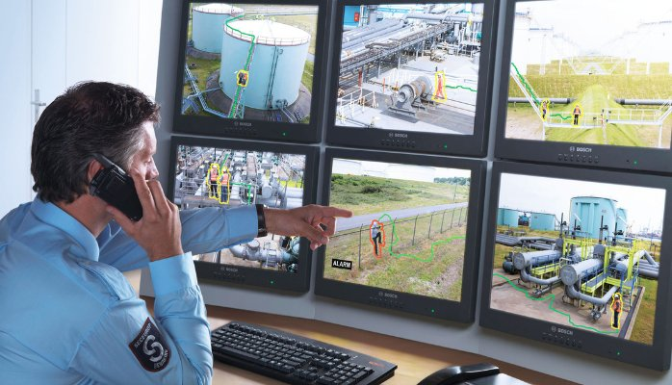
Fig.1.1
Chapter 2
Review of Literature

PAPER-1

PAPER TOPIC: - SMART SURVEILLANCE MONITORING SYSTEM USING RASPBERRY PI AND PIR SENSOR

AUTHOR - SANJANA PRASAD , P.MAHALAKSHMI , A.JOHN CLEMENT SUNDER , R.SWATHI

PAPER PUBLICATION DETAILS - INTERNATIONAL JOURNAL OF COMPUTER SCIENCE AND INFORMATION TECHNOLOGIES, VOL. 5 (6) , 2014, 7107-7109

ABSTRACT:
THIS PAPER DEALS WITH THE DESIGN AND IMPLEMENTATION OF SMART SURVEILLANCE MONITORING SYSTEM USING RASPBERRY PI AND PIR SENSOR FOR MOBILE DEVICES. IT INCREASES THE USAGE OF MOBILE TECHNOLOGY TO PROVIDE ESSENTIAL SECURITY TO OUR HOMES AND FOR OTHER CONTROL APPLICATIONS . THE PROPOSED HOME SECURITY SYSTEM CAPTURES INFORMATION AND TRANSMITS IT VIA A 3G DONGLE TO A SMART PHONE USING WEB APPLICATION. RASPBERRY PI OPERATES AND CONTROLS MOTION DETECTORS AND VIDEO CAMERAS FOR REMOTE SENSING AND SURVEILLANCE, STREAMS LIVE VIDEO AND RECORDS IT FOR FUTURE PLAYBACK. IT CAN ALSO FIND THE NUMBER OF PERSONS LOCATED WITH THE HELP OF THE INFRARED SENSOR.. FOR EXAMPLE , WHEN MOTION IS DETECTED, THE CAMERAS AUTOMATICALLY INITIATE RECORDING AND THE RASPBERRY PI DEVICE ALERTS THE OWNER OF THE POSSIBLE INTRUSION HAVING A SMART PHONE. RASPBERRY- PI HAS TWO MAIN COMPONENTS INTERACTING WITH EACH OTHER: ONE IS THE WEB APPLICATION THAT EXECUTES ON THE MOBILE DEVICE'S BROWSER AND SERVER-SIDE SCRIPTS THAT RUN IN A CLOUD WHICH WILL BE OPERATED BY THE RASPBERRY PI HARDWARE TOOL COMPONENT.

WORKING

THE WORKING OF THIS PROJECT STARTS WITH A DATA SET GENERATION FOR CREATING 50-75 SAMPLES LIKELY ALTERABLE BY THE PROGRAM.THEN WE WILL TRAIN THE SAMPLES USING HAARCASCADE ALGORITHM.NEXT COMES THE DETECTION PART WHEREIN THE SUSPECCT IS WELL DETECTED AND WILL INFORM VIA SMS WHICH IS TAKEN FROM GATEWAY SERVER.OUTPUT IS SHOWN GENERATING OPEN-CV LIBRARIES IN RASBPERRY PI.

WE HAVE DESIGNED A SMART SURVEILLANCE SYSTEM CAPABLE F RECORDING/CAPTURING VIDEO/IMAGE AND TRANSMITTING TO A MART PHONE.IT IS ADVANTAGEOUS AS IT OFFERS RELIABILITY AND RIVACY ON BOTH SIDES. IT IS AUTHENTICATED AND ENCRYPTED ON HE RECIEVER SIDE,HENCE IT OFFERS ONLY THE PERSON CONCERNED O VIEW THE DETAILS .NECCESARY ACTION CAN BE TAKEN IN SHORT PAN OF TIME IN THE CASE OF EMERGENCY CONDITIONS SUCH AS ELDERLY PERSON FALLING SICK,MILITARY AREAS,SMART HOMES,OFFICES,INDUSTRIES ETC.,FUTURE WORK IS TO LOCATE THE NUMBER OF PERSONS LOCATED EXACTLY ON THAT AREA AND THEIR POSITION SO THAT ACCURATE INFORMATION CAN BE OBTAINED ON HE RECEIVER SIDE.

PAPER-2

PAPER TOPIC: - SMART SURVEILLANCE MONITORING SYSTEM USING RASPBERRY PI AND PIR SENSOR

AUTHOR - N.SUGUMARAN1 , G.V.VIJAY2 , E.ANNADEVI3
PAPER PUBLICATION DETAILS -INTERNATIONAL JOURNAL OF INNOVATIVE RESEARCH IN ADVANCED ENGINEERING (IJIRAE)
ABSTRACT:
THE SECURITY IS A SCENARIO IN WHICH OBJECTS, ANIMALS OR PEOPLE ARE PROVIDED WITH UNIQUE IDENTIFIERS AND THE ABILITY TO TRANSFER DATA OVER A NETWORK WITHOUT REQUIRING HUMAN-TO-HUMAN OR HUMAN-TO-COMPUTER INTERACTION. THE WEBCAM HAS EVOLVED FROM THE CONVERGENCE OF WIRELESS TECHNOLOGIES AND THE INTERNET. THE SECURITY SYSTEM IS THE COMMUNICATION OF ANYTHING WITH ANY OTHER THING, THE COMMUNICATION MAINLY TRANSFERRING OF USEABLE DATA, FOR EXAMPLE, A SENSOR IN A ROOM TO MONITOR AND CONTROL THE TEMPERATURE. TO DESCRIBE A SECURITY ALARM SYSTEM USING LOW PROCESSING POWER CHIPS USING INTERNET OF THINGS WHICH HELPS TO MONITOR AND GET ALARMS WHEN MOTION IS DETECTED AND SENDS PHOTOS AND VIDEOS TO A CLOUD SERVER. MOREOVER, INTERNET OF THINGS BASED APPLICATION CAN BE USED REMOTELY TO VIEW THE ACTIVITY AND GET NOTIFICATIONS WHEN MOTION IS DETECTED. THE PHOTOS AND VIDEOS ARE SENT DIRECTLY TO A CLOUD SERVER WHEN THE CLOUD IS NOT AVAILABLE THEN THE DATA IS STORED LOCALLY ON THE RASPBERRY PI AND SENT WHEN THE CONNECTION RESUMES. THEREFORE, ADVANTAGES LIKE THESE MAKE THIS APPLICATION IDEAL FOR MONITORING HOMES IN ABSENCE.
PROPOSED SYSTEM
THIS PAPER DEALS WITH THE DESIGN AND IMPLEMENTATION OF SMART SURVEILLANCE MONITORING SYSTEM USING RASPBERRY PI AND PIR SENSOR FOR MOBILE DEVICES. IT INCREASES THE USAGE OF MOBILE TECHNOLOGY TO PROVIDE ESSENTIAL SECURITY TO OUR HOMES AND FOR OTHER CONTROL APPLICATIONS. THE PROPOSED HOME SECURITY SYSTEM CAPTURES INFORMATION AND TRANSMITS IT TO THE RESPECTIVE MAIL USING THE INTERNET. RASPBERRY PI OPERATES AND CONTROLS MOTION DETECTORS AND VIDEO CAMERAS FOR REMOTE SENSING AND SURVEILLANCE, STREAMS LIVE VIDEO AND RECORDS IT FOR FUTURE PLAYBACK. IT CAN ALSO FIND THE NUMBER OF PERSONS LOCATED WITH THE HELP OF THE INFRARED SENSOR. FOR EXAMPLE, WHEN MOTION IS DETECTED, THE CAMERAS AUTOMATICALLY INITIATE RECORDING AND THE RASPBERRY PI DEVICE ALERTS THE OWNER OF THE POSSIBLE INTRUSION HAVING A SMART PHONE. RASPBERRY- PI HAS TWO MAIN COMPONENTS INTERACTING WITH EACH OTHER. WE CAN ABLE SEND IT TO THE EMAIL AUTOMATICALLY. WE CAN ABLE TO ALERT THE PEOPLE USING IOT TECHNOLOGY
CONCLUSION
HENCEFORTH, BY ENHANCING THE CAPABILITIES OF THESE TECHNOLOGIES AND INTEGRATING THEM, WE HOPE TO INTRODUCE THE 'MOTION DETECTION' SYSTEM AND TO CONTRIBUTE TO THE CURRENT SECURITY SYSTEM. THIS SYSTEM WOULD BE AN ALTERNATIVE FOR EXPENSIVE SECURITY SYSTEMS BEING USED IN THE PRESENT DAY. THIS SYSTEM DOES NOT REQUIRE ANY SPECIAL MODIFICATIONS TO THE INFRASTRUCTURE WHERE INSTALLATION IS REQUIRED AND CAN BE IMPLEMENTED WITHOUT ANY HASSLE. I HAVE TESTED THESE SYSTEM FOR180 DAYS AND HAVE FOUND 99.9% ACCURATE NOTIFICATIONS AND RESULTS .

CHAPTER 3
Theory And Methodology
WORKING:
THE OVERALL WORKING OF THE CAMERA CAN BE EXPLAINED WITH THE HELP OF A FLOWCHART. THE IMAGE IS CAPTURED BY THE PICAMERA WHICH HAS 5MP PIXEL RESOLUTION WITH 30 FPS, THIS IMAGE IS THEN SENT TO THE FACE DETECTION MODULE, WHICH CHECKS THE FRAME OBTAINED FOR ANY FACES THAT CAN BE FOUND WITH THE HELP OF THE HAAR LIKE FEATURES, IF THE FACE IS DETECTED THEN IT IS CROPPED OUT.
HAAR-LIKE FEATURES ARE DIGITAL IMAGE FEATURES USED IN OBJECT RECOGNITION. THEY OWE THEIR NAME TO THEIR INTUITIVE SIMILARITY.

IMPLEMENTATION
STEP1:

SETTING UP RASPBERRY PI BEGIN BY SLOTTING THE SD CARD INTO THE SD CARD SLOT ON THE RASPBERRY PI, WHICH WILL ONLY FIT ONE WAY. NEXT, PLUG THE USB KEYBOARD AND USB MOUSE INTO THE USB SLOTS ON THE RASPBERRY PI. MAKE SURE THAT THE MONITOR OR TV IS TURNED ON, AND THAT THE RIGHT INPUT IS SELECTED. THEN CONNECT THE HDMI CABLE FROM YOUR RASPBERRY PI TO THE MONITOR OR TV. IF THE RASPBERRY PI IS NEEDED TO BE CONNECTED TO THE INTERNET, PLUG AN HDMI-VGA INTO THE HDMI-VGA PORT NEXT TO THE USB PORTS. WHEN ALL THE REQUIRED CABLES AND SD CARD ARE PLUGGED THEN, PLUG IN THE MICRO USB POWER SUPPLY.

STEP2:

CREATING DATABASES
LETS CREATE THE DATASET GENERATOR SCRIPT, OPEN YOUR PYTHON IDLE AND CREATE A NEW FILE AND SAVE IT IN YOUR PROJECT FOLDER AND MAKE SURE YOU ALSO HAVE THE HAARCASCADE_FRONTALFACE_DEFAULT.XML FILE IN THE SAME FOLDERJUST LIKE IN THE PREVIOUS POST WE WILL NEED TO DO THE FOLLOWING FIRST:
- CV2 LIBRARY (OPENCV LIBRARY)
- CREATE A VIDEO CAPTURE OBJECT
- CASCADECLASSIFIER OBJECT
SO HERE IT IS IN FORM OF PYTHON CODE.
IMPORT CV2
CAM = CV2.VIDEOCAPTURE(0)
DETECTOR=CV2.CASCADECLASSIFIER('HAARCASCADE_FRONTALFACE_DEFAULT.XML')

STEP3:

DETECTING THE FACE
FACE DETECTION IS A PSYCHOLOGICAL PROCESS BY WHICH HUMANS LOCATE AND ATTEND FACES IN A VISUAL SCENE. ONCE THE CAMERA CAPTURES THE IMAGE OF AN OBJECT THE CAPTURED IMAGE IS STORED. OPENCV IS USED FOR FACIAL DETECTION OPENCV IS WRITTEN IN C, BUT THERE ARE BINDINGS FOR PYTHON AND ACTUALLY PHP. DETECTING THE FACE FROM AN IMAGE AND CROPPING IMAGES, WITHOUT CUTTING OUT FACES. IN THIS PROJECT, PYTHON CODE IS USED FOR DETECTING FACES. IT IS DONE BY INSTALLING OPENCV AND THE PYTHON BINDINGS AND THEN WRITING A QUICK SCRIPT TO DETECT FACES IN AN IMAGE. AN XML FILE WITH TRAINING DATA FOR THE PROGRAM IS NEEDED. DOWNLOAD THE HAAR CASCADE FRONTAL FACE PACKAGE FOR OPENCV. THIS PACKAGE IS USED FOR DETECTING FACE FROM AN
IMAGE.

BLOCK DIAGRAM
FIGURE 1:
TRAINING DATASET

MOTION DETECTED
CAPTURE IMAGE
PROCESS IMAGE

UNAUTHORIZED PERSON?
GIVES INFORMATION
YES

NO

NO NOTIFICATION

FIGURE 2 :
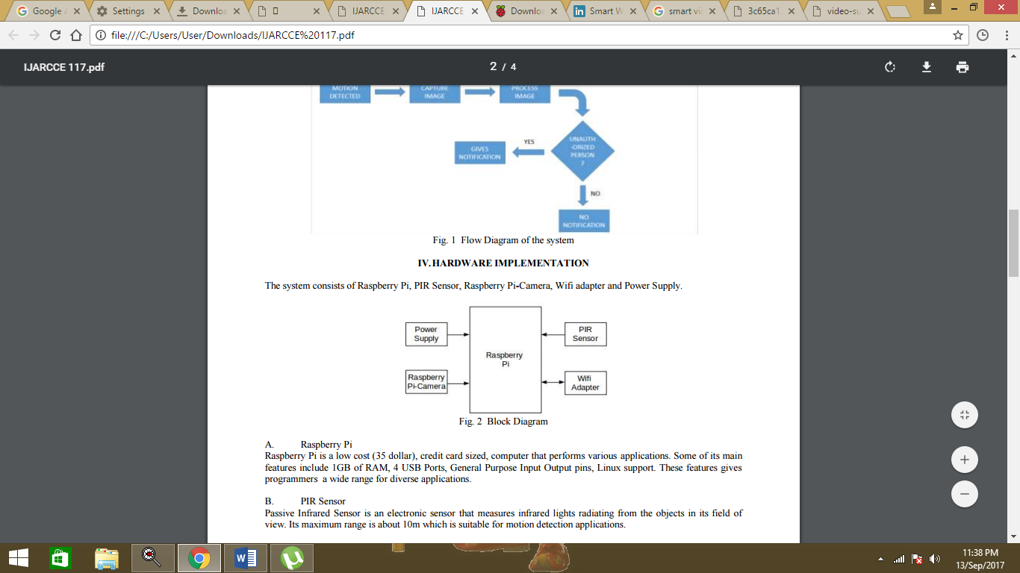

TECH USED
Sr No. | Name | Type
1. | WEBCAM | HARDWARE
2. | RASPBERRY PIE | HARDWARE
3. | PIE CHARGER | HARDWARE
4. | MEMORY CARD – 16 GB | HARDWARE
5. | CONNECTOR WIRE FOR PIE | HARDWARE
6. | COMPUTER OR OTHER MONITORING DEVICE | HARDWARE
7. | EDIMAX WIFI-USB ADAPTER | HARDWARE
7. | OPEN CV | SOFTWARE
8. | PYCHARM COMMUNITY | SOFTWARE

COMPONENTS USED
RASPBERRY PI A SMALL CREDIT-CARD SIZED COMPUTER CAPABLE OF PERFORMING VARIOUS FUNCTIONALITIES SUCH AS IN SURVEILLANCE SYSTEMS, MILITARY APPLICATIONS,
SPECIFICATIONS B+
RASPBERRY PI CAMERA MODULE
• 5 MP CAMERA EXCLUSIVELY MADE FOR RASPBERRY PI
• CAN TAKE 1080P HIGH DEFINITION VIDEOS
• SMALL IN SIZE AND CAN BE CONNECTED DIRECTLY TO THE RASPBERRY PI BOARD.
• 1080P, 780P AND ALSO STILL PICTURES.
SD CARD
• RASPBERRY PI HAS NO STORAGE ON BOARD.
• SD/MICRO SD CARD STORES THE OS. THE TOTAL MEMORY OF THE SD CARD IS ABOUT 8GB.
• CLASS 10 IS PREFERRED OWING TO ITS HIGH SPEED.
NETWORK ADAPTER
• WIRELESS NETWORK CONNECTION IS USED FOR THE PROCESS OF DATA TRANSFER.
• WI-FI USB ADAPTER THAT SUPPORTS SPEED OF 150MBPS IS USED.
• EDIMAX IS A COMMONLY USED WI-FI USB ADAPTER.
POWER SUPPLY
• A MICRO-USB PLUG POWER SUPPLY THAT SUPPLIES AT LEAST 1A OF POWER IS USED
• IT ALSO RUNS ON A BATTERY.

Description Of Tech :
1. Pi Camera or Webcam
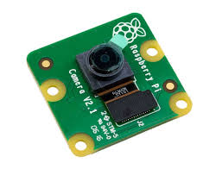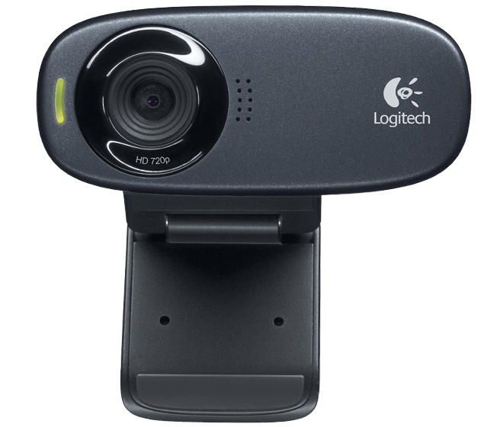
FIG.3.1
The Raspberry Pi Camera Board V2 Is A High Quality 8 Megapixel Sony Imx219 Image Sensor Custom Designed Add-On Board For Raspberry Pi, Featuring A Fixed Focus Lens. It's Capable Of 3280 X 2464 Pixel Static Images, And Also Supports 1080p30, 720p60, And 640x480p90 Video.It Attaches To The Pi By Way Of One Of The Small Sockets On The Board's Upper Surface And Uses The Dedicated Csi Interface, Designed Especially For Interfacing To Cameras.Webcams Are Known For Their Low Manufacturing Cost And Their High Flexibility,Making Them The Lowest-Cost Form Of Videotelephony. Despite The Low Cost, The Resolution Offered At Present (2015) Is Rather Impressive, With Low-End Webcams Offering Resolutions Of 320×240, Medium Webcams Offering 640×480 Resolution, And High-End Webcams Offering 1280×720 (Aka 720p) Or Even 1920×1080 (Aka 1080p) Resolution.
2. Pi Charger
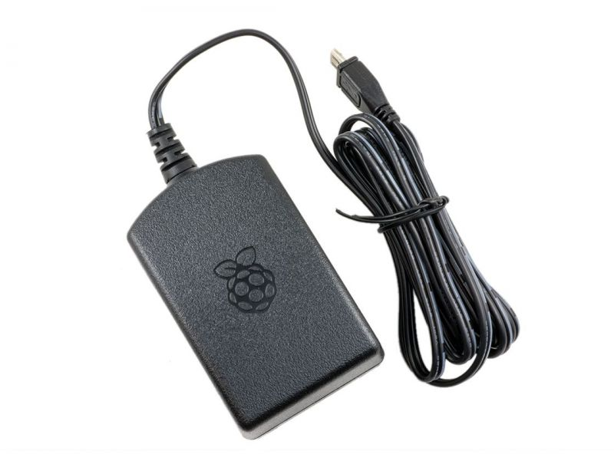FIG.3.2
A Usb Adapter Is A Type Of Protocol Converter Which Is Used For Converting Usb Data Signals To And From Other Communications Standards. Commonly, Usb Adaptors Are Used To Convert Usb Data To Standard Serial Port Data And Vice Versa
2. Raspberry Pi
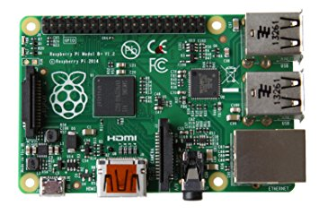 FIG3.3
Raspberry Pi Model B
The Raspberry Pi® Is A Single-Board Computer Developed In The Uk By The Raspberry Pi Foundation With The Intention Of Stimulating The Teaching Of Basic Computer Science In Schools. The Raspberry Pi Is A Credit-Card Sized Computer That Plugs Into Your Tv And A Keyboard.
4. SD card
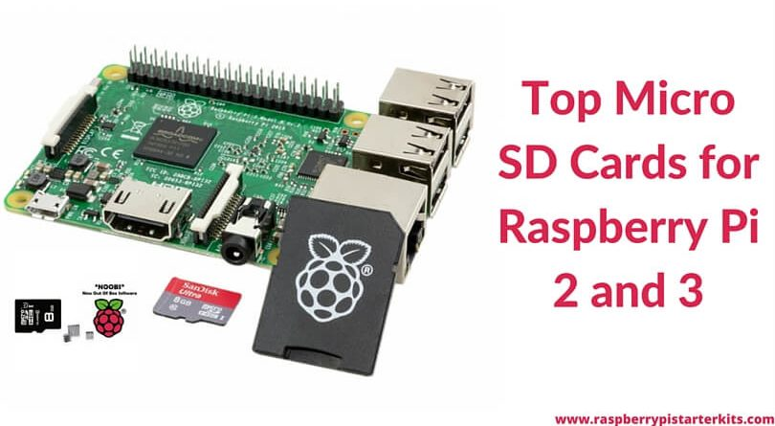 FIG3.4

There Are Adapters That Make The Small Microsd Able To Fit In Devices That Have Slots For Standard Sd, Minisd, Memory Stick Duo Card, And Even Usb.

5. Connector Wire For Pi
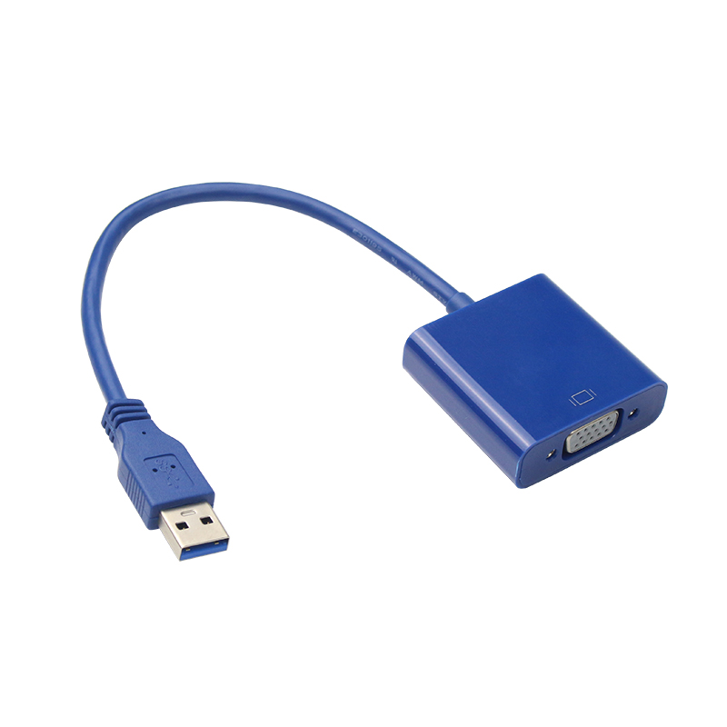FIG3.5
Hdmi-To-Dvi Cables Are Also Passive, But They Carry Digital Signals Only. The Analog Rgb Signals Are Missing, But That Does Not Matter As The Dvi Monitor Does Not Need Them. Hdmi Contains No Analog Signal So It Is Not Possible For Any Combination Of Passive Adapters And/Or Cables To Convert It To Vga.

6. Computer With Raspbian OS
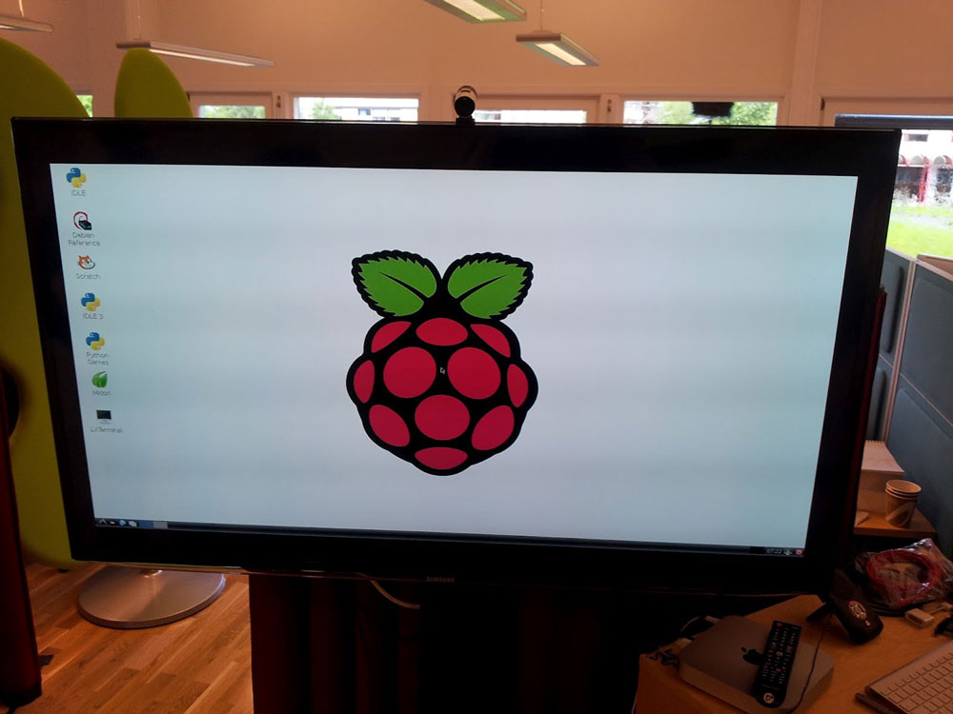
FIG 3.6
Raspbian Is A Debian-Based Computer Operating System For Raspberry Pi. There Are Several Versions Of Raspbian Including Raspbian Stretch And Raspbian Jessie.

6. Edimax Wifi-USB Adapter
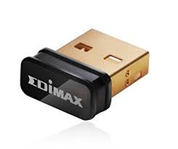 FIG83.7

7.Open CV

Opencv (Open Source Computer Vision) Is A Library Of Programming Functions Mainly Aimed At Real-Time Computer Vision. Originally Developed By Intel, It Was Later Supported By Willow Garage Then Itseez The Library Is Cross-Platform And Free For Use Under The Open-Source BSD License.

8.Pycharm Community For Python Coding

Pycharm Is An Integrated Development Environment (IDE) Used In Computer Programming, Specifically For The Python Language.

MORE ABOUT
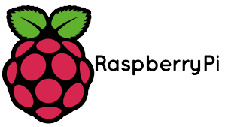

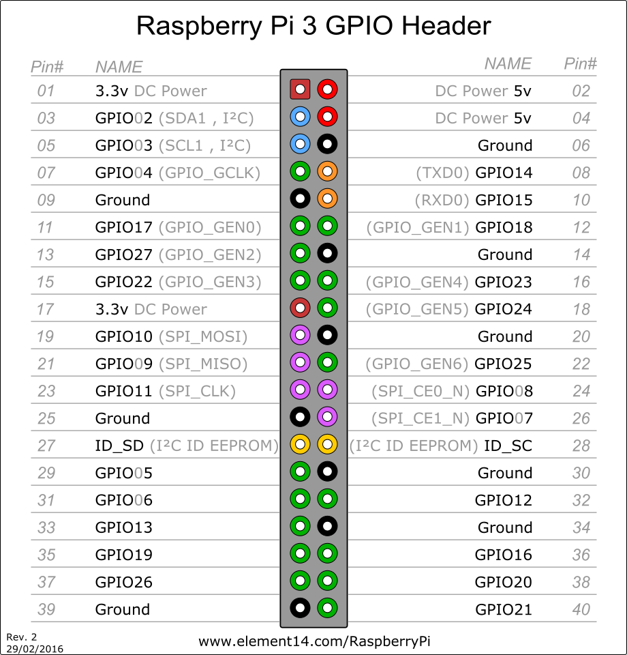
RASPBERRY PI IS A CREDIT-CARD SIZED COMPUTER MANUFACTURED AND DESIGNED IN THE UNITED KINGDOM BY THE RASPBERRY PI FOUNDATION WITH THE INTENTION OF TEACHING BASIC COMPUTER SCIENCE TO SCHOOL STUDENTS AND EVERY OTHER PERSON INTERESTED IN COMPUTER HARDWARE, PROGRAMMING AND DIY-DO-IT YOURSELF PROJECTS.
THE RASPBERRY PI IS MANUFACTURED IN THREE BOARD CONFIGURATIONS THROUGH LICENSED MANUFACTURING DEALS WITH NEWARK ELEMENT14 (PREMIER FARNELL), RS CMPONENTS AND EGOMAN. THESE COMPANIES SELL THE RASPBERRY PI ONLINE. EGOMAN PRODUCES A VERSION FOR DISTRIBUTION SOLELY IN CHINA AND TAIWAN, WHICH CAN BE DISTINGUISHED FROM OTHER PIS BY THEIR RED COLORING AND LACK OF FCC/CE MARKS. THE HARDWARE IS THE SAME ACROSS ALL MANUFACTURERS.
THE RASPBERRY PI HAS A BROADCOM BCM2835 SYSTEM ON A CHIP (SOC), WHICH INCLUDES AN ARM1176JZF-S 700 MHZ PROCESSOR, VIDEOCORE IV GPU AND WAS ORIGINALLY SHIPPED WITH 256 MEGABYTES OF RAM, LATER UPGRADED (MODEL B & MODEL B+) TO 512 MB. IT DOES NOT INCLUDE A BUILT-IN HARD DISK OR SOLID-STATE DRIVE, BUT IT USES AN SD CARD FOR BOOTING AND PERSISTENT STORAGE, WITH THE MODEL B+ USING A MICROSD.
THE FOUNDATION PROVIDES DEBIAN AND ARCH LINUX ARM DISTRIBUTIONS FOR DOWNLOAD. TOOLS ARE AVAILABLE FOR PYTHON AS THE MAIN PROGRAMMING LANGUAGE, WITH SUPPORT FOR BBC BASIC (VIA THE RISC OS IMAGE OR THE BRANDY BASIC CLONE FOR LINUX), C, JAVA AND PERL.

A BRIEF DESCRIPTION OF THE COMPONENTS ON THE PI.
- PROCESSOR / SOC (SYSTEM ON CHIP)

THE RASPBERRY PI HAS A BROADCOM BCM2835 SYSTEM ON CHIP MODULE. IT HAS A ARM1176JZF-S PROCESSOR.THE BROADCOM SOC USED IN THE RASPBERRY PI IS EQUIVALENT TO A CHIP USED IN AN OLD SMARTPHONE (ANDROID OR IPHONE). WHILE OPERATING AT 700 MHZ BY DEFAULT, THE RASPBERRY PI PROVIDES A REAL WORLD PERFORMANCE ROUGHLY EQUIVALENT TO THE 0.041 GFLOPS. ON THE CPU LEVEL THE PERFORMANCE IS SIMILAR TO A 300 MHZ PENTIUM II OF 1997-1999, BUT THE GPU, HOWEVER, PROVIDES 1 GPIXEL/S, 1.5 GTEXEL/S OR 24 GFLOPS OF GENERAL PURPOSE COMPUTE AND THE GRAPHICS CAPABILITIES OF THE RASPBERRY PI ARE ROUGHLY EQUIVALENT TO THE LEVEL OF PERFORMANCE OF THE XBOX OF 2001. THE RASPBERRY PI CHIP OPERATING AT 700 MHZ BY DEFAULT, WILL NOT BECOME HOT ENOUGH TO NEED A HEATSINK OR SPECIAL COOLING.
- POWER SOURCE

THE PI IS A DEVICE WHICH CONSUMES 700MA OR 3W OR POWER. IT IS POWERED BY A MICROUSB CHARGER OR THE GPIO HEADER. ANY GOOD SMARTPHONE CHARGER WILL DO THE WORK OF POWERING THE PI
- SD CARD

THE RASPBERRY PI DOES NOT HAVE ANY ONBOARD STORAGE AVAILABLE. THE OPERATING SYSTEM IS LOADED ON A SD CARD WHICH IS INSERTED ON THE SD CARD SLOT ON THE RASPBERRY PI. THE OPERATING SYSTEM CAN BE LOADED ON THE CARD USING A CARD READER ON ANY COMPUTER.
- GPIO

GPIO – GENERAL PURPOSE INPUT OUTPUT
GENERAL-PURPOSE INPUT/OUTPUT (GPIO) IS A GENERIC PIN ON AN INTEGRATED CIRCUIT WHOSE BEHAVIOUR, INCLUDING WHETHER IT IS AN INPUT OR OUTPUT PIN, CAN BE CONTROLLED BY THE USER AT RUN TIME.GPIO PINS HAVE NO SPECIAL PURPOSE DEFINED, AND GO UNUSED BY DEFAULT. THE IDEA IS THAT SOMETIMES THE SYSTEM DESIGNER BUILDING A FULL SYSTEM THAT USES THE CHIP MIGHT FIND IT USEFUL TO HAVE A HANDFUL OF ADDITIONAL DIGITAL CONTROL LINES, AND HAVING THESE AVAILABLE FROM THE CHIP CAN SAVE THE HASSLE OF HAVING TO ARRANGE ADDITIONAL CIRCUITRY TO PROVIDE THEM.

GPIO CAPABILITIES MAY INCLUDE:
- GPIO PINS CAN BE CONFIGURED TO BE INPUT OR OUTPUT

- GPIO PINS CAN BE ENABLED/DISABLED

- INPUT VALUES ARE READABLE (TYPICALLY HIGH=1, LOW=0)

- OUTPUT VALUES ARE WRITABLE/READABLE

- INPUT VALUES CAN OFTEN BE USED AS IRQS (TYPICALLY FOR WAKEUP EVENTS)

THE PRODUCTION RASPBERRY PI BOARD HAS A 26-PIN 2.54 MM (100 MIL) EXPANSION HEADER, MARKED AS P1, ARRANGED IN A 2X13 STRIP. THEY PROVIDE 8 GPIO PINS PLUS ACCESS TO I²C, SPI, UART), AS WELL AS +3.3 V, +5 V AND GND SUPPLY LINES. PIN ONE IS THE PIN IN THE FIRST COLUMN AND ON THE BOTTOM ROW.
5) DSI CONNECTOR
THE DISPLAY SERIAL INTERFACE (DSI) IS A SPECIFICATION BY THE MOBILE INDUSTRY PROCESSOR INTERFACE (MIPI) ALLIANCE AIMED AT REDUCING THE COST OF DISPLAY CONTROLLERS IN A MOBILE DEVICE. IT IS COMMONLY TARGETED AT LCD AND SIMILAR DISPLAY TECHNOLOGIES. IT DEFINES A SERIAL BUS AND A COMMUNICATION PROTOCOL BETWEEN THE HOST (SOURCE OF THE IMAGE DATA) AND THE DEVICE (DESTINATION OF THE IMAGE DATA).
A DSI COMPATIBLE LCD SCREEN CAN BE CONNECTED THROUGH THE DSI CONNECTOR, ALTHOUGH IT MAY REQUIRE ADDITIONAL DRIVERS TO DRIVE THE DISPLAY.
6)RCA VIDEO
RCA VIDEO OUTPUTS (PAL AND NTSC) ARE AVAILABLE ON ALL MODELS OF RASPBERRY PI. ANY TELEVISION OR SCREEN WITH A RCA JACK CAN BE CONNECTED WITH THE RPI.
- AUDIO JACK
A STANDARD 3.5 MM TRS CONNECTOR IS AVAILABLE ON THE RPI FOR STEREO AUDIO OUTPUT. ANY HEADPHONE OR 3.5MM AUDIO CABLE CAN BE CONNECTED DIRECTLY. ALTHOUGH THIS JACK CANNOT BE USED FOR TAKING AUDIO INPUT, USB MICS OR USB SOUND CARDS CAN BE USED
- STATUS LEDS

THERE ARE 5 STATUS LEDS ON THE RPI THAT SHOW THE STATUS OF VARIOUS ACTIVITIES AS FOLLOWS:
―OK‖ - SDCARD ACCESS (VIA GPIO16) - LABELLED AS "OK" ON MODEL B REV1.0 BOARDS AND "ACT" ON MODEL B REV2.0 AND MODEL A BOARD.
―POWER‖ - 3.3 V POWER - LABELLED AS "PWR" ON ALL BOARDS
CODES USED:
1. DATA GENERATOR
CODE:

import cv2
cam = cv2.VideoCapture(0)
detector=cv2.CascadeClassifier('Classifiers/face.xml')
i=0
offset=50
name=raw_input('enter your id')
while True:
ret, im =cam.read()
gray=cv2.cvtColor(im,cv2.COLOR_BGR2GRAY)
faces=detector.detectMultiScale(gray, scaleFactor=1.2, minNeighbors=5, minSize=(100, 100), flags=cv2.CASCADE_SCALE_IMAGE)
for(x,y,w,h) in faces:
i=i+1
cv2.imwrite("dataSet/face-"+name +'.'+ str(i) + ".jpg", gray[y-offset:y+h+offset,x-offset:x+w+offset])
cv2.rectangle(im,(x-50,y-50),(x+w+50,y+h+50),(225,0,0),2)
cv2.imshow('im',im[y-offset:y+h+offset,x-offset:x+w+offset])
cv2.waitKey(100)
if i>50:
cam.release()
cv2.destroyAllWindows()
break

2. Data Trainer
Code:
import cv2,os
import numpy as np
from PIL import Image

recognizer = cv2.face.LBPHFaceRecognizer_create()
cascadePath = "Classifiers/face.xml"
faceCascade = cv2.CascadeClassifier(cascadePath);
path = 'dataSet'

def get_images_and_labels(path):
image_paths = [os.path.join(path, f) for f in os.listdir(path)]
# images will contains face images
images = []
# labels will contains the label that is assigned to the image
labels = []
for image_path in image_paths:
# Read the image and convert to grayscale
image_pil = Image.open(image_path).convert('L')
# Convert the image format into numpy array
image = np.array(image_pil, 'uint8')
# Get the label of the image
nbr = int(os.path.split(image_path)[1].split(".")[0].replace("face-", ""))
#nbr=int(''.join(str(ord(c)) for c in nbr))
print nbr
# Detect the face in the image
faces = faceCascade.detectMultiScale(image)
# If face is detected, append the face to images and the label to labels
for (x, y, w, h) in faces:
images.append(image[y: y + h, x: x + w])
labels.append(nbr)
cv2.imshow("Adding faces to traning set...", image[y: y + h, x: x + w])
cv2.waitKey(10)
# return the images list and labels list
return images, labels

images, labels = get_images_and_labels(path)
cv2.imshow('test',images[0])
cv2.waitKey(1)

recognizer.train(images, np.array(labels))
recognizer.write('trainer/trainer.yml')
cv2.destroyAllWindows()

3. Data Detector:
Code:
import cv2,os
import numpy as np
from PIL import Image
import pickle
import urllib2
import time
recognizer = cv2.face.LBPHFaceRecognizer_create()
recognizer.read('trainer/trainer.yml')
cascadePath = "Classifiers/face.xml"
faceCascade = cv2.CascadeClassifier(cascadePath);
path = 'dataSet'
cam = cv2.VideoCapture(0)
font = cv2.FONT_HERSHEY_SIMPLEX
while True:
ret, im =cam.read()
gray=cv2.cvtColor(im,cv2.COLOR_BGR2GRAY)
faces=faceCascade.detectMultiScale(gray, scaleFactor=1.2, minNeighbors=5, minSize=(100, 100), flags=cv2.CASCADE_SCALE_IMAGE)
time.sleep(1)
for(x,y,w,h) in faces:
nbr_predicted, conf = recognizer.predict(gray[y:y+h,x:x+w])
cv2.rectangle(im,(x-50,y-50),(x+w+50,y+h+50),(225,0,0),2)
if(nbr_predicted==1):
nbr_predicted='Chintan'
elif(nbr_predicted==2):
nbr_predicted='SK'
elif(nbr_predicted==3):
nbr_predicted='Terror--Rahul'
response = urllib2.urlopen("https://www.smsgatewayhub.com/api/mt/SendSMS?APIKey=c5a0a9b5-24a5-49b7-9a45-77a9ab765f99&senderid=TESTIN&channel=1&DCS=0&flashsms=0&number=9022484764&text=SuspectFound")
html = response.read()
print(html)
cv2.putText(im,str(nbr_predicted)+"--", (x,y+h),font, 1, (255,255,255), 3)
cv2.imshow('im',im)
cv2.waitKey(10)

#import urllib2
#urllib2.urlopen("https://www.google.com/")
#urllib2.urlopen("https://www.smsgatewayhub.com/api/mt/SendSMS?APIKey=c5a0a9b5-24a5-49b7-9a45-77a9ab765f99&senderid=TESTIN&channel=1&DCS=0&flashsms=0&number=9022484764&text=Suspect Found")

ALL PROPOSED OUTPUTS:

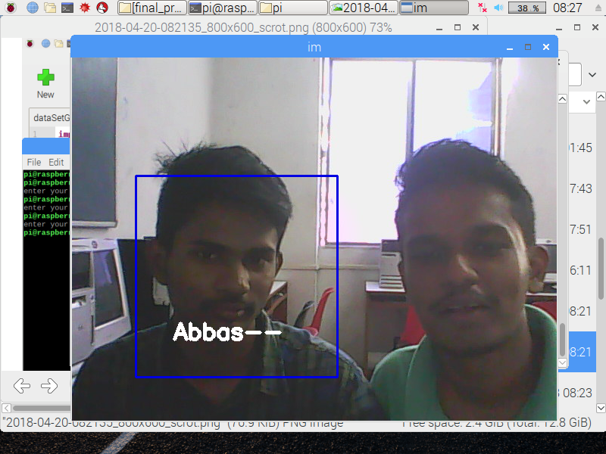

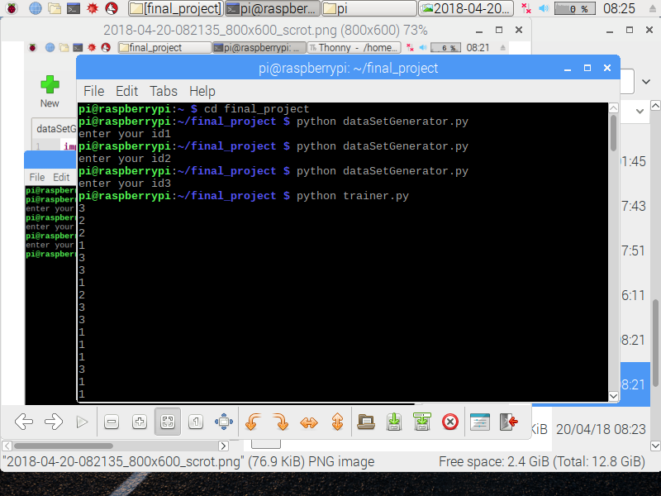
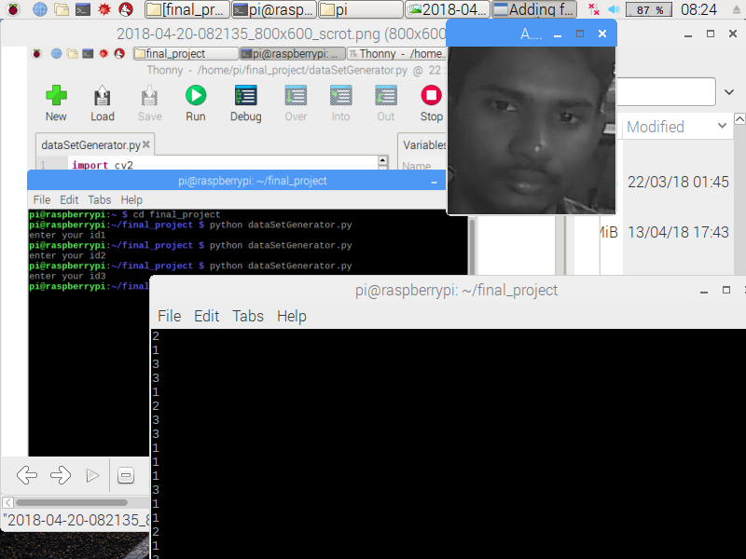
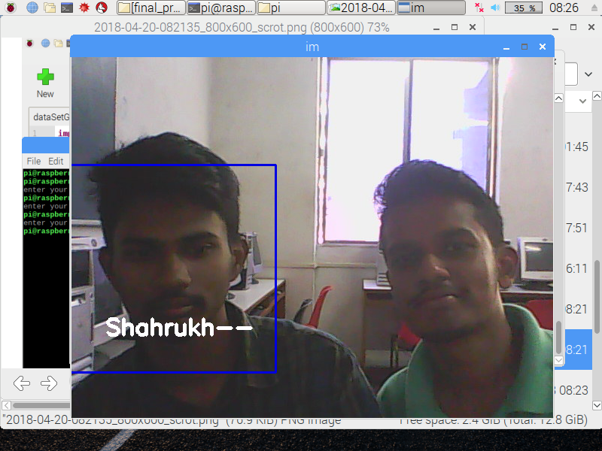

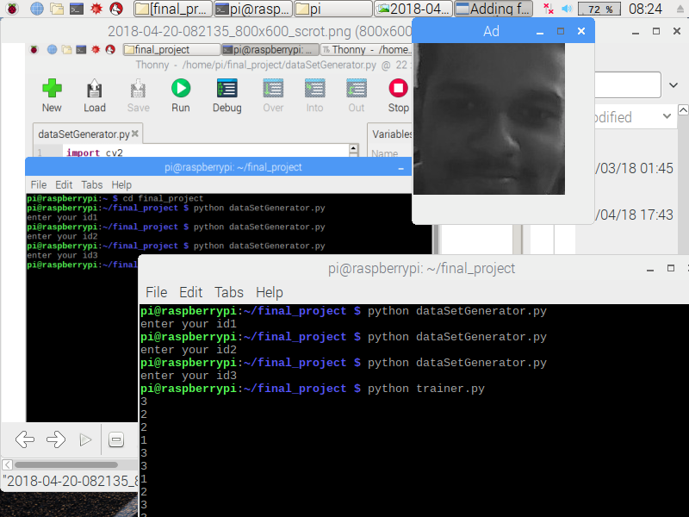
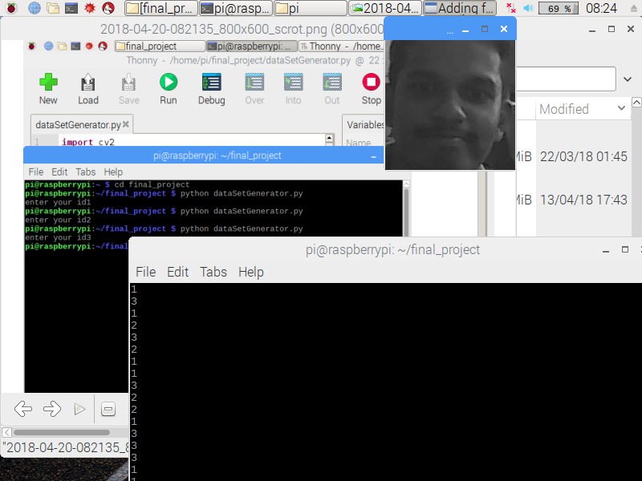
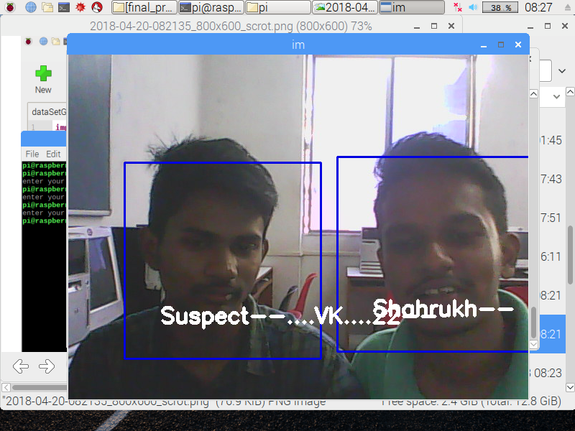

CHAPTER 4
Results and Discussions
• THERE ARE A THOUSAND THINGS WE CAN DO WITH SUCH A SURVEILLANCE CAM BASIC SETUP NOW.
• SENDING GROWL NOTIFICATIONS WHEN SOME MOTION WAS DETECTED
• OR WE COULD EASILY ADD A TEMPERATURE-SENSOR TO THE CAM AND CAN BE INTEGRATED VERY EASILY.
• IF YOU WANT EXTRA SECURITY, YOU COULD ALSO ADD A BATTERY PACK TO THE CAMERA. THE ONE THAT IS ABLE TO CHARGE SIMULTANEOUSLY WHILE POWERING THE RASPBERRY. THIS WOULD ENABLE YOU TO DETECT IF SOME BAD GUY CUTS THE POWER STRIPS OF YOUR CAMERA AND SEND SOME ALERT MESSAGES TO YOU (I.E. SMS OR EMAIL) INCLUDING THE VIDEO OF THE DISTURBER.

CHAPTER 5
Future Scope
WE HAVE CHOSEN THIS PROJECT WITH THE INTENTION THAT IT WILL BE VIABLE FOR FUTURE USE.RASPBERRY PI DEVELOPMENT BOARD IS A COST EFFECTIVE FULLY FUNCTIONAL COMPUTATIONAL SYSTEM CAN BE USED FOR MANY APPLICATIONS. PIR MOTION SENSOR AND CAMERA MODULES ARE ALSO COST EFFECTIVE AND CAN BE USED FOR SURVEILLANCE SYSTEMS.
USING PYTHON AND OPENCV IN RASPBERRY PI, MADE OUR PROJECT FLEXIBLE AND ADOPTABLE TO ANY REQUIRED FUTURE CHANGES. DETECTED FACES CAN BE STORED IN CLOUD AND CAN BE USED FOR RECOGNIZING THE FACES IS THE FUTURE SCOPE.
USING RASPBERRY PI THECURRENT PROJECT CAN BE MODIFIED BY AN INFRARED CAMERA INTERFACING IT CAN BE USED IN SMART SURVEILLANCE MONITORING SECURITY SYSTEM WHICH ANY TYPE OF PUBLIC SECURITY IS USING LIVING BODY DETECTION OR SPYING
ALSO IT CAN BE USED IN ATTENDANCE SYSTEM OF THE CLASS, ALSO SOME PROFOUND APPLICATIONS CAN BE IMPLEMENTED USING INTERFACING OF RASPBERRY PI AND ARDUINO UNO BOARD LIKE SENSOR APPLICATION OF SMARTCARD SWAPPING, FINGER DETECTION, ALCOHOL DETECTION, AGRICULTURE HUMIDITY SENSING, TEMPERATURE SENSING USING WEBSERVER, AND MANY MORE.

ADVANTAGES:
IN CCTV SYSTEMS THERE SHOULD BE A DEDICATED PC FOR THE MODULE WHICH IS ELIMINATED HERE.A PC CAN BE HACKED AND THE FILES CAN BE ERASED WHILE THIS SYSTEM OVERCOMES THOSE PROBLEMS.
IN THIS SYSTEM, AUTHENTICATION IS REQUIRED ON THE USER SIDE INORDER TO VIEW THE STREAMED VIDEO IN THE BROWSER. VERY LESS EXPENSIVE WHEN COMPARED TO THE OTHER EXISTING SYSTEMS.
IN THIS SYSTEM, A WIDE AREA CAN BE CAPTURED.THE CAMERA MOTION CAN BE CONTROLLED BY THE USER.

DISADVANTAGES
SIMPLIFY YOUR LIFE.A RASPBERRY PI SECURITY SYSTEM HAS THE ABILITY TO SEND NOTIFICATIONS TO YOUR SMART PHONE WITH A MOTION DETECTING SURVEILLANCE CAMERA. YOU CAN EVEN PROGRAM IT WITH FACIAL RECOGNITION CAPABILITIES. HOWEVER, THIS WILL NOT ACTUALLY STOP AN INTRUDER FROM ENTERING YOUR HOME. THESE DEVICES THAT YOU CAN MAKE WILL ONLY LET YOU KNOW THAT SOMEONE HAS GAINED ACCESS TO YOUR DWELLING. OUR PROBLEM NOW IS THAT THIS STILL ISN'T FAST ENOUGH AND WE'RE UNSURE WHERE THE BOTTLENECK IS. FACIAL DETECTION ON OUR PI3B IS 1.5S FOR AN EMPTY FRAME, 2.8S FOR ONE FACE, AND 4.5S FOR 2 FACES. THIS IS NOT NEARLY FAST ENOUGH FOR REAL TIME .
ALSO AFTER OUR UNFEIGNED EFFORTS , THE PI3B CANNOT DETECT IF THERE IS ANY CLOSE RESEMBLANCE BETWEEN TWO DIFFERENT PERSONA.

APPENDIX
OPENCV AND THE FACE RECOGNITION ALGORITHM
FOR THE FACIAL RECOGNITION, WE CHOSE TO USE OPENCV LIBRARY TO REALIZE THE IMAGE PROCESSING AND FACE RECOGNITION TASKS. IT IS A VERY POWERFUL LIBRARY OF COMPUTER VISION PROGRAMMING FUNCTIONS. THE FIRST THING WE NEED TO CONSIDER IN THIS PART IS CHOOSING A PROPER FACE RECOGNITION ALGORITHM. THERE ARE TWO POPULAR FACE RECOGNITION ALGORITHMS INCLUDED IN OPENCV, THE HAAR CASCADE AND LOCAL BINARY PATTERNS (LBP). WE ARE USING THE LBP METHOD IN THIS PROJECT BECAUSE ITS FEATURES ARE SIMPLER IN CONTRAST TO HAAR’S FEATURES AND BOTH THE TRAINING AND DETECTION WITH LBP ARE SEVERAL TIMES FASTER THAN HAAR (SOURCE). MORE DETAILED DESCRIPTIONS OF THESE TWO ALGORITHMS CAN BE FOUND HERE. THESE TWO ALGORITHMS BOTH USE AN XML FILE TO RECORD THE FEATURES OF THE OBJECT WE WANT TO DETECT. THE OPENCV LIBRARY HAS ALREADY INCLUDED SOME WELL-TRAINED XML FILES FOR FACE AND BODY PART DETECTION. ALSO, WITH THE HELP OF OPENCV, WE COULD TRAIN OUR OWN LBP OR HAAR CLASSIFIERS AND GENERATE THE XML CASCADE FILES. IN OTHER WORDS, IT IS POSSIBLE TO TRAIN A CLASSIFIER TO DETECT ANY OBJECT WE WANT. THE NAOTOSHI SEO’S BLOG ON OPENCV HAAR TRAINING IS A VERY GOOD TUTORIAL OF GENERATING YOUR OWN HAAR CLASSIFIERS (SOURCE). HOWEVER, NAOTOSHI SEO ALSO WARNED THAT THE TRAINING TIME MAY BE HORRIBLY LONG AND IT TOOK HIM ONE WEEK TO GENERATE HIS OWN XML FILE. SO, IF YOU WANT TO GENERATE YOUR OWN CLASSIFIER, BE SURE TO PLAN AHEAD AND USE ENOUGH TRAINING SETS.
AFTER CHOOSING THE PROPER FACE RECOGNITION ALGORITHM, ANOTHER PROBLEM WE HAD TO SOLVE WAS HOW TO ACCESS THE PI CAMERA. THE PI CAMERA IS CONNECTED TO PROCESSOR VIA THE CSI BUS. IT’S QUITE DIFFERENT FROM THE USB CAMERA AND THE OPENCV LIBRARY COULDN’T ACCESS TO IT DIRECTLY. SO, WE NEED TO USE THE PI CAMERA PACKAGE TO HELP US ACCESS THE CAMERA MODULE. THE PI CAMERA LIBRARY PROVIDES MANY USEFUL FUNCTIONS SUCH AS CAPTURING AN IMAGE AND CONVERTING IT INTO AN OPENCV OBJECT. WITH THE HELP OF PICAMERA, WE CAN CAPTURE IMAGES OR VIDEOS, CONVERT THEM INTO OPENCV OBJECT, AND THEN CONDUCT THE IMAGE PROCESSING AND FACE RECOGNITION FUNCTION. YOU CAN INSTALL THE PICAMERA BY RUNNING:
1  2  3 | $ SUDO APT-GET INSTALL PYTHON-PIP  $ SUDO APT-GET INSTALL PYTHON-DEV  $ SUDO PIP INSTALL PICAMERA
IF YOU DON’T LIKE THE PI CAMERA, INSTALLING THE UV4L DRIVER IS AN ALTERNATIVE WAY TO ACCESS THE PI CAMERA. THIS DRIVER COULD CREATE A NEW DEVICE AS /DEV/VIDEO0 AND THE SYSTEM WILL REGARD THE PI CAMERA AS A USB CAMERA. THUS THE OPENCV COULD ACCESS THE PI CAMERA MODULE DIRECTLY FROM /DEV/VIDEO0. THIS WEBSITE DESCRIBES IN DETAIL HOW TO INSTALL AND USE THE UV4L DRIVER.
IN THE END WE CHOSE TO GO WITH THE PI CAMERA LIBRARY SINCE WE FOUND IT EASIER TO USE AND IT HAD SIMPLE INSTRUCTIONS TO CONVERT THE IMAGES CAPTURED BY THE PI CAMERA TO AN OPENCV OBJECT.
HOWEVER WE STRONGLY BELIEVE THAT BY TRAINING THE SYSTEM, OVER TIME OUR DESIGN SHOULD BE ABLE TO MEET THIS GOAL AS WELL.
ULTIMATELY WE ARE VERY PLEASED WITH THE RESULTS. WE WERE ABLE TO DESIGN AND BUILD THIS SYSTEM FROM SCRATCH. WE WERE ABLE TO MEET MOST OF OUR OBJECTIVES AND IN THE END WE PRODUCED A SYSTEM THAT WORKS.

ACKNOWLEDGEMENTS
I AM PROFOUNDLY GRATEFUL TO PROF. DR. VARSHA SHAH FOR HIS EXPERT GUIDANCE AND CONTINUOUS ENCOURAGEMENT THROUGHOUT TO SEE THAT THIS PROJECT RIGHTS ITS TARGET.

I WOULD LIKE TO EXPRESS DEEPEST APPRECIATION TOWARDS DR. VARSHA SHAH, PRINCIPAL RCOE, MUMBAI WHOSE INVALUABLE GUIDANCE SUPPORTED ME IN THIS PROJECT.

AT LAST I MUST EXPRESS MY SINCERE HEARTFELT GRATITUDE TO ALL THE STAFF MEMBERS OF COMPUTER ENGINEERING DEPARTMENT WHO HELPED US DIRECTLY OR INDIRECTLY DURING THIS COURSE OF WORK.

ABBAS ALI
RAHIM KORBO
SHAHRUKH PADANIYA
VISHAL KERKAR

CHAPTER 5
REFERENCES
[1] MS. NAGA JYOTI AND MR. K. VIJAYA VARDHAN, “DESIGN AND IMPLEMENTATION OF REAL TIME SECURITY SURVEILLANCE SYSTEM USING IOT”, COMMUNICATION AND ELECTRONICS SYSTEMS (ICCES), INTERNATIONAL CONFERENCE: IEEE, 2016.
[2] M. SURYA DEEKSHITH GUPTA, VAMSIKRISHNA PATCHAVA, AND VIRGINIA MENEZES: “SURVEILLANCE AND MONITORING SYSTEM USING RASPBERRY PI AND SIMPLECV”: GREEN COMPUTING AND INTERNET OF THINGS (ICGCIOT), IEEE, 2016.
[3] ARUNI SINGH, SANJAY KUMAR SINGH, SHRIKANT TIWARI, “COMPARISON OF FACE RECOGNITION ALGORITHMS ON DUMMY FACES”, THE INTERNATIONAL JOURNAL OF MULTIMEDIA & ITS APPLICATIONS (IJMA) VOL.4, NO.4, AUGUST 2012.
[4] AAMIR NIZAM ANSARI, MOHAMED SEDKY, NEELAM SHARMA, ANURAG TYAGI, “AN INTERNET OF THINGS APPROACH FOR MOTION DETECTION USING RASPBERRY PI”, INTERNATIONAL CONFERENCE ON INTELLIGENT COMPUTING AND INTERNET OF THINGS (IC1T), 2015.
[5] R.CHANDANA, DR.S.A.K.JILANI, MR.S.JAVEED HUSSAIN, “SMART SURVEILLANCE SYSTEM USING THING SPEAK AND RASPBERRY PI”, INTERNATIONAL JOURNAL OF ADVANCED RESEARCH IN COMPUTER AND COMMUNICATION ENGINEERING VOL. 4, ISSUE 7, JULY 2015.
[6] SANJANA PRASAD, P.MAHALAKSHMI, A.JOHN CLEMENT SUNDER, R.SWATHI, “SMART SURVEILLANCE MONITORING SYSTEM USING RASPBERRY PI AND PIR SENSOR”, (IJCSIT) INTERNATIONAL JOURNAL OF COMPUTER SCIENCE AND INFORMATION TECHNOLOGIES, 2014.
[7] HUU-QUOC NGUYEN, TON THI KIM LOAN, BUI DINH MAO, EUI-NAM HUH, “LOW COST REAL-TIME SYSTEM MONITORING USING RASPBERRY PI”, IEEE, 2015
[8] SARABJIT SINGH, AMRITPAL KAUR, T AQDIR, “A FACE RECOGNITION TECHNIQUE USING LOCAL BINARY PATTERN METHOD”, INTERNATIONAL JOURNAL OF ADVANCED RESEARCH IN COMPUTER AND COMMUNICATION ENGINEERING, 2015.
[9] SUSHMA JAISWAL, DR. (SMT.) SARITA SINGH BHADAURIA , DR. RAKESH SINGH JADON, “ COMPARISON BETWEEN FACE RECOGNITION ALGORITHM-EIGENFACES, FISHERFACES AND ELASTIC BUNCH GRAPH MATCHING ”, JOURNAL OF GLOBAL RESEARCH IN COMPUTER SCIENCE, 2011
[10] HTTPS://EN.WIKIPEDIA.ORG/WIKI/IMAGE_PROCESSING [11] HTTPS://EN.WIKIPEDIA.ORG/WIKI/LOCAL_BINARY_PATTERNS

